To do:
- implement webpage > https://hieromon.github.io/AutoConnect/acintro.html
- find out which IP address is used by the ESP32 after AutoConnect

Electrical hardware
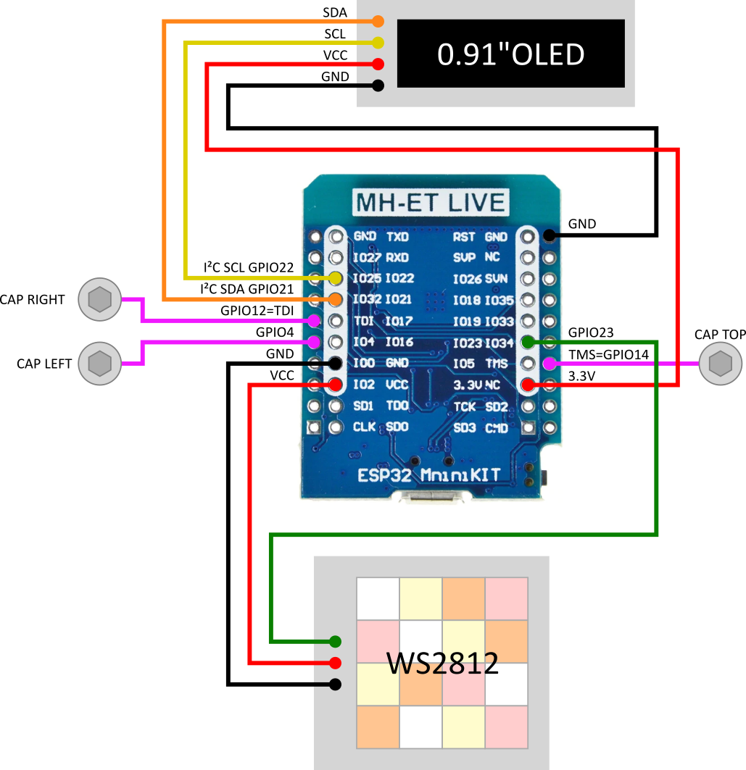

Webserver - website
https://developer.mozilla.org/en-US/docs/Learn/Common_questions/Pages_sites_servers_and_search_engines

General flow of the program
PowerState can be:
- psOn
- psOff
- psTimer
psTimer is controlled by the countDown variable, then switches to psOff

ColorState can be:
- csWhite
- csRed
- csOrange
- csYellow

IntensityState can be:
- is10
- is15
- is20
- is40
- is60
- is100

Autoconnect
- Enbles the ESP32 to connect to a Wii access point without hardcodig the SSID and password.
- It stores all previously known access points
- It first tries to establish a connection to a known access point
- If there is no known access point:
  - it creates an access point with a webserver named “esp32ap” and password “12345678”
  - the user can access this access point, select an SSID and provide a password
  - Autoconnect then connects the ESP32 to that access point

https://hieromon.github.io/AutoConnect/faq.html

